TASK 1:
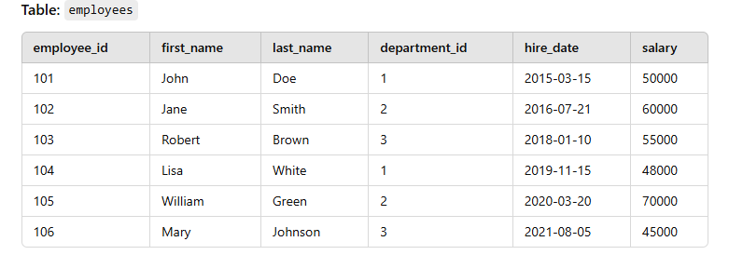
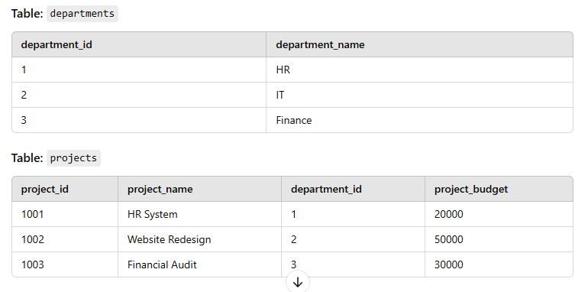

Assignment:
- List the names of employees who were hired between 2015-01-01 and 2020-12-31 and belong to departments with names starting with "H".
Select a.first_name||' '||a.last_name as Names from
employees a left join departments b on a.department_id = b.department_id
where a.hire_date between date '2015-01-01' and date '2020-12-31' and
b.department_name like 'H%';
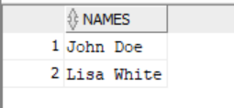
- For each department, show the department name and the total salary of employees in that department who were hired after 2017-01-01.
select b.department_name, sum(a.salary) as total_salary from
departments b left join employees a on a.department_id=b.department_id
where a.hire_date > date '2017-01-01' group by b.department_name; 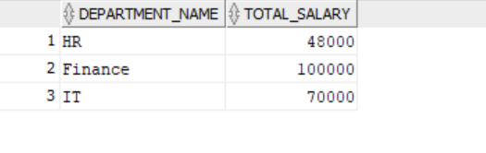

- Find the employees whose last name starts with "B" or "J", and their first names contain "an".
select * from employees where first_name like '%an%' AND (last_name like 'B%' OR last_name like 'J%');
- Show the first 3 characters of the first name and last name of employees, along with their department name for all employees in the Finance department who have a salary greater than 45000.
select substr(a.first_name,1,3)||' '|| substr(a.last_name,1,3) as short_name, b.department_name as department_name
from employees a left join departments b on a.department_id = b.department_id where a.salary>45000 and b.department_name='Finance';
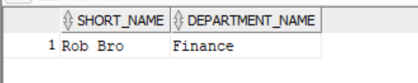
- Retrieve the project names, the department name for each project, and a comma-separated list of employee names (first and last) who are working on those projects, where the project budget is more than 25000.

select c.project_name,b.department_name, listagg(a.first_name||' '||a.last_name,',') as employees
from projects c left join departments b on c.department_id=b.department_id
left join employees a on a.department_id=b.department_id where c.project_budget >25000
group by c.project_name, b.department_name;
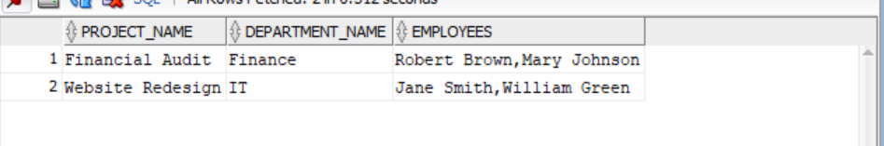

- Find the departments whose names contain the substring "IT" or "HR" and have a project budget of more than 30000.
select a.department_name from departments a left join projects b
on a.department_id=b.department_id where b.project_budget>30000 and
(a.department_name like '%IT%' or a.department_name like '%HR%');
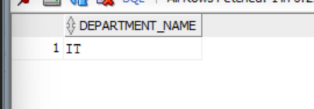
- Find the departments where the combined salaries of employees hired before 2017- 01-01 are greater than 100000.’

select b.department_name,sum(a.salary) as combined_salary
from departments b left join employees a on a.department_id=b.department_id
where a.hire_date < date '2017-01-01' group by b.department_name having sum(a.salary)>100000;



- List all employees whose names contain "a" (case-insensitive), and who belong to departments with a name that starts with "T".
Select a.first_name||' '||a.last_name as Names from
employees a left join departments b on a.department_id = b.department_id
where (a.first_name like '%a%' or a.first_name like '%A%'
or a.last_name like '%a%' or a.last_name like '%A%') and
b.department_name like 'T%';
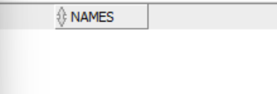
- For each department, show the department name and a comma-separated list of employee names (first and last) who have a salary greater than 55000.
select a.department_name , listagg(b.first_name||' '||b.last_name,',') as employees from
departments a left join employees b on a.department_id= b.department_id
where b.salary>55000 group by a.department_name;
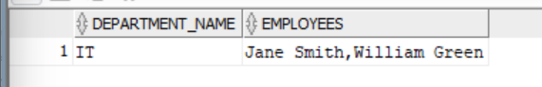
- Get the department names and the first two characters of the employees' first names for those hired after 2020-01-01, where the department's name contains the string "e".
select a.department_name,substr(b.first_name,1,2) as short_name from
departments a left join employees b on a.department_id=b.department_id
where b.hire_date> date '2020-01-01' and a.department_name like '%e%';
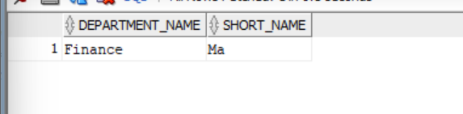
- Retrieve a list of projects with their project names, budgets, and department names, where the project budget is between 20000 and 50000.
select a.project_name, a.project_budget, b.department_name from
projects a left join departments b on a.department_id=b.department_id
where a.project_budget between 20000 and 50000;
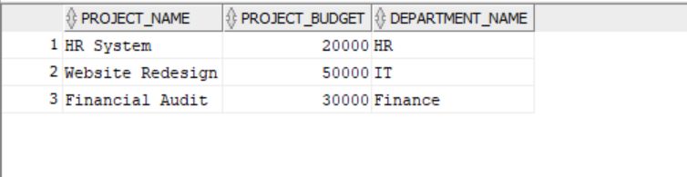
- List all employees whose first name contains exactly 4 characters, and their salary is within the top 3 salaries in the company.
select * from
(select a.*, dense_rank() over (order by a.salary desc) as rank from employees a) ranked
where rank<=3 and first_name like '____';
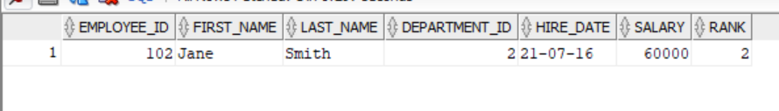
- For each project, show the project name, budget, and the names of employees (first and last) working on the project, excluding those whose names start with "J".
select c.project_name , c.project_budget, listagg(a.first_name||' '||a.last_name,',') as employees
from projects c left join departments b on c.department_id=b.department_id
left join employees a on a.department_id=b.department_id where a.first_name not like 'J%'
group by c.project_name,c.project_budget;
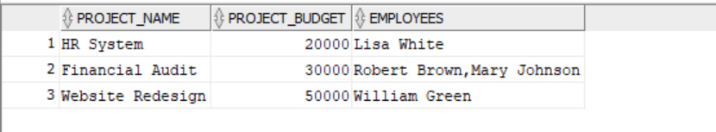

- Find the employees who have both "a" and "e" in their first names, and who belong to departments where the department name ends with "n".
Select a.*, b.* from
employees a left join departments b on a.department_id = b.department_id
where (a.first_name like '%a%e' or a.first_name like '%e%a%') and
b.department_name like '%n';
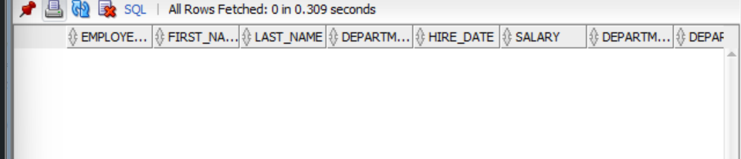

- Retrieve the names of employees, their departments, and the number of characters in their last names for employees who were hired between 2016-01-01 and 2018-12-31.
Select a.first_name||' '||a.last_name, b.department_name, length(a.last_name) as number_char_in_lastname from
employees a left join departments b on a.department_id = b.department_id
where a.hire_date between date '2016-01-01' and date '2018-12-31' ;
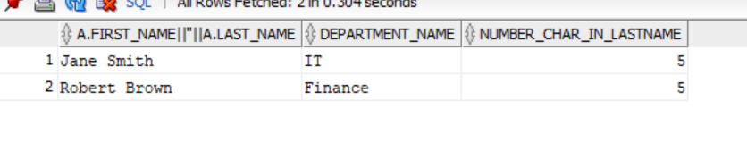
- Show the department names, and the names of employees who were hired in the last two years and earn less than 60000.
select a.department_name, listagg(b.first_name||' '||b.last_name, ',') as employees from
employees b right join departments a on a.department_id = b.department_id
where round(months_between(sysdate,b.hire_date)/12) <=2 and b.salary<60000 group by a.department_name;
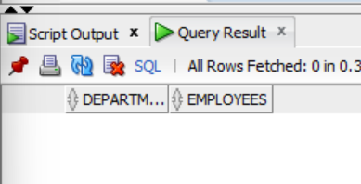

- For each department, list the department name and a comma-separated list of employee names, who were hired after 2017-01-01 and whose last name contains the substring "on".
select a.department_name, listagg(b.first_name||' '||b.last_name, ',') as employees from
employees b right join departments a on a.department_id = b.department_id
where b.hire_date> date '2017-01-01' and b.last_name like '%on%' group by a.department_name;
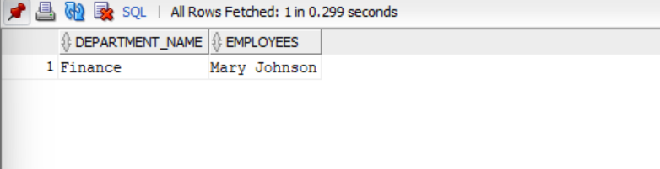
- Get the department name, employee names (first and last), and salary for employees who have a salary that is greater than the average salary in their respective department.
select a.department_name, listagg(b.first_name||' '||b.last_name, ',') as employees from
employees b right join departments a on a.department_id = b.department_id
where b.salary>(select avg(e.salary) from employees e where department_id=a.department_id)
group by a.department_name;
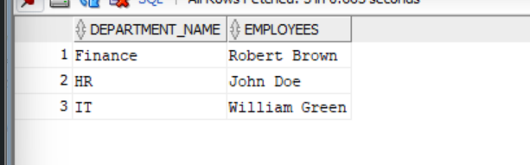
- List the department names and the total number of employees who have a salary between 40000 and 60000.
select a.department_name, count(a.department_name) as employees_count from
employees b right join departments a on a.department_id = b.department_id
where salary between 40000 and 60000 group by a.department_name;
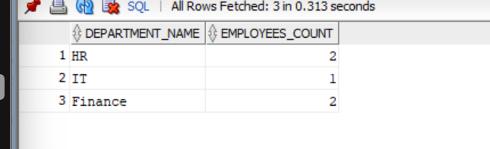
- Find the projects whose names start with "Web" and whose budgets are in the range 20000 to 40000 and show the department name for each project.
select a.project_name, b.department_name from
projects a left join departments b on a.department_id=b.department_id
where a.project_name like 'Web%' and a.project_budget between 20000 and 40000;
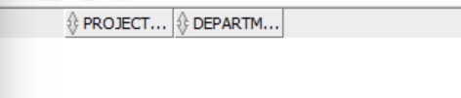

TASK 2:
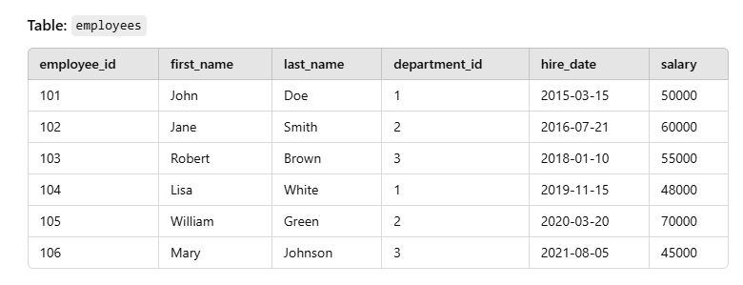
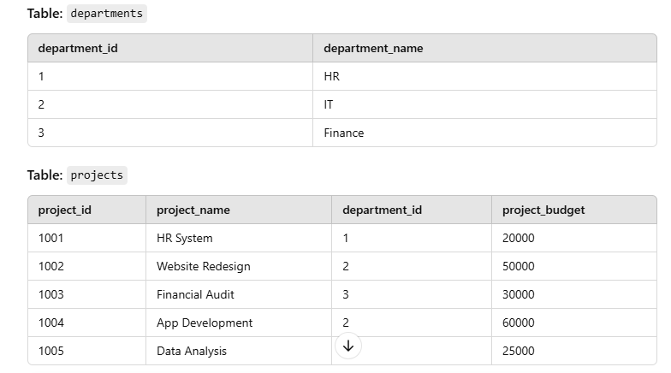

1. List the employees who belong to departments that are not in HR or Finance and were hired between 2017-01-01 and 2021-12-31.
select a.first_name||' '||a.last_name as Employee_names from
employees a left join departments b on a.department_id=b.department_id
where b.department_name not in ('HR','Finance') and
a.hire_date between date '2017-01-01' and date '2021-12-31';
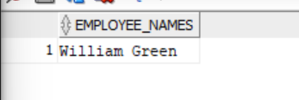
2. Retrieve the employees whose first names start with 'J' and their last names contain 'e', using the LIKE clause and escape characters.
select * from employees where first_name like 'J%' and last_name like '%e%';
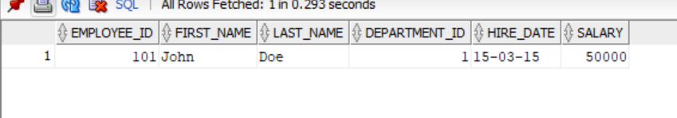
3. Find the projects that have budgets not between 20000 and 50000, and show their project names and associated department names.
select a.* , b.department_name from
projects a left join departments b on a.department_id=b.department_id
where a.project_budget not between 20000 and 50000 ;
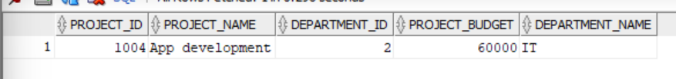

4. List the department names where the department name contains the letter 'e' (case-insensitive) and the budget of their projects is between 30000 and 60000.
select b.department_name from
projects a right join departments b on a.department_id=b.department_id
where (a.project_budget between 30000 and 60000) and
(b.department_name like '%e%' or b.department_name like '%E%');
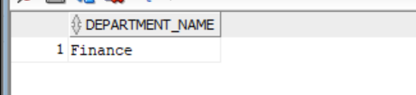
5. Find the employees who were hired before 2018-01-01 and whose salary is not within the range of 45000 to 60000 (inclusive).
select * from employees where hire_date< date '2018-01-01' and
salary not between 45000 and 60000;
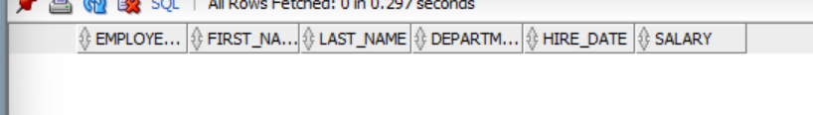
6. Retrieve the project names and budgets where the department names contain the word "IT" and the project budget is greater than 40000.
select a.project_name from
projects a left join departments b on a.department_id=b.department_id
where a.project_budget >40000 and
b.department_name like '%IT%';
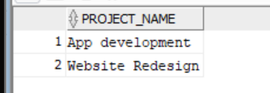
7. Find the employees who were hired between 2016-01-01 and 2020-12-31 and have either a salary of 50000 or 55000.
select * from employees where
hire_date between date '2016-01-01' and date '2020-12-31' and
salary in (50000,55000);
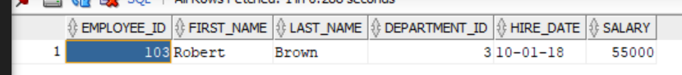
8. Get the employees who are in departments with names that do not contain the substring 'e' and whose last names end with the letter 'n'.
select a.*,b.department_name from
employees a left join departments b on a.department_id=b.department_id
where b.department_name not like '%e%' and a.last_name like '%n';
9. Retrieve the names of employees who have a first name with 4 characters, their salary is greater than 60000, and they belong to either the 'IT' or 'HR' department.
select a.*,b.department_name from
employees a left join departments b on a.department_id=b.department_id
where b.department_name in ('IT','HR') and a.first_name like '____'
and a.salary>60000;
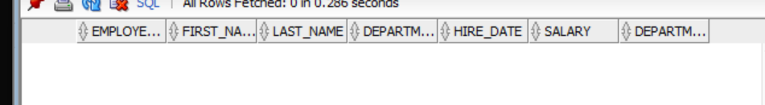
10. List the departments whose names contain a wildcard character like '%' and their project budgets are within 30000 and 50000.
select distinct(b.department_name) from
projects a right join departments b on a.department_id=b.department_id
where (a.project_budget between 30000 and 50000) and
(b.department_name like '%\%%' escape '\');
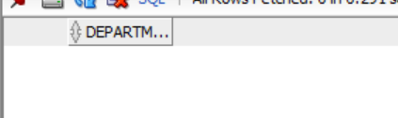
11. Find the employees whose first names start with 'A' and last names end with 'n', excluding employees in departments whose names contain 'IT'.
select a.* from
employees a left join departments b on a.department_id=b.department_id
where b.department_name='%IT%' and
a.first_name='A%' and a.last_name='%n';
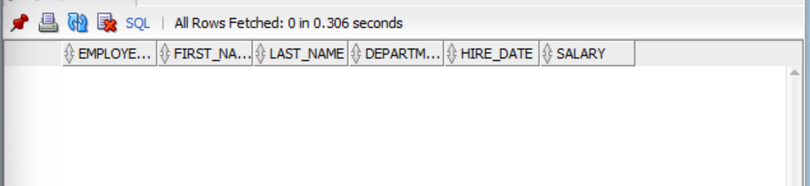
12. Retrieve the departments with names starting with 'H' or 'F' and the corresponding project names whose budget is less than 30000.
select distinct(b.department_name) from
projects a right join departments b on a.department_id=b.department_id
where (a.project_budget < 30000 ) and
(b.department_name like 'H%' or b.department_name like 'F%');
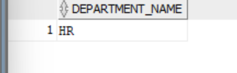
13. Get the department names where the department name starts with 'F' and contains more than 6 characters, and there are projects with a budget greater than 25000.
select distinct(b.department_name) from
projects a right join departments b on a.department_id=b.department_id
where (a.project_budget > 25000 ) and
(b.department_name like 'F%' and b.department_name like '_______%');
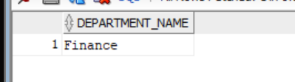

14. Retrieve the project names and budgets where the project name starts with 'A', and the project budget is either between 20000 and 40000, or greater than 60000.
select a.project_name,a.project_budget from
projects a left join departments b on a.department_id=b.department_id
where (a.project_budget between 20000 and 40000 or a.project_budget>60000) and
a.project_name like 'A%';
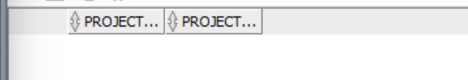
15. Find the employees who were hired before 2019-01-01 and whose first names contain exactly 4 characters, excluding those in departments starting with 'F'.
select a.* , b.department_name from
employees a left join departments b on a.department_id=b.department_id
where b.department_name not like 'F%' and
a.first_name like '____' and
a.hire_date <date '2019-01-01';
